**Group #3 Term Project (Part II): Visualization of Chemical Analysis of Soil and Water Samples**

**Part I:**

**Group Member Names:**

Ryan Renken

Sameer Khan

Ajay Singh

**Link to the Visualization:**

<https://rrenken.github.io/6260_proj4_wetlands_Group3/>

**Part II: Detailed explanation of the visualization implementation.**

**Menu:**

* The menu is fixed at the top of the screen with buttons for soil and water. Users can switch between options to view visualization for soil and data.



**Visualization 1: (Map Visualization)**

* This Visualization Shows

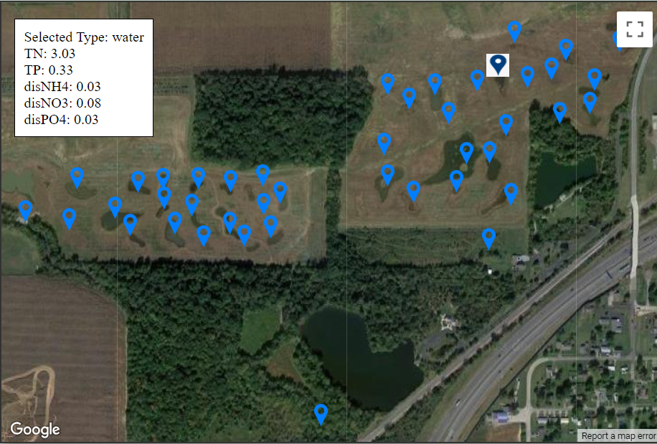 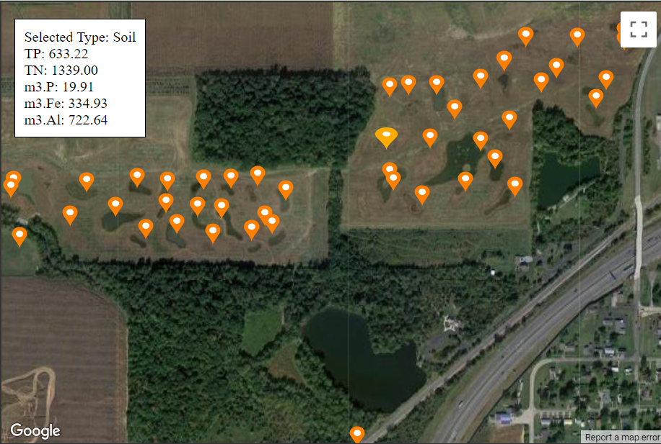

**Visualization 2 (Scatter plot):**

* This visualization displays how the water or soil chemical parameters have changed over time.
* You can view the data either for the entire duration or for a specific period.
* Use the slider located at the bottom to select the desired date range, there are two sliders one for start date and one for end date.
* Using the time button, you can easily visualize the data you need, whether it's for a specific year, two years, or all the data. This feature makes it simple to find the information you're looking for.
* Using dropdowns, you can effortlessly choose the field type and parameters that suit your needs.
* When hovering over a data point, additional details about the sample are displayed including location coordinates, visit date, field name, sample date, and sample note.
* While, clicking on a data point displays related information.

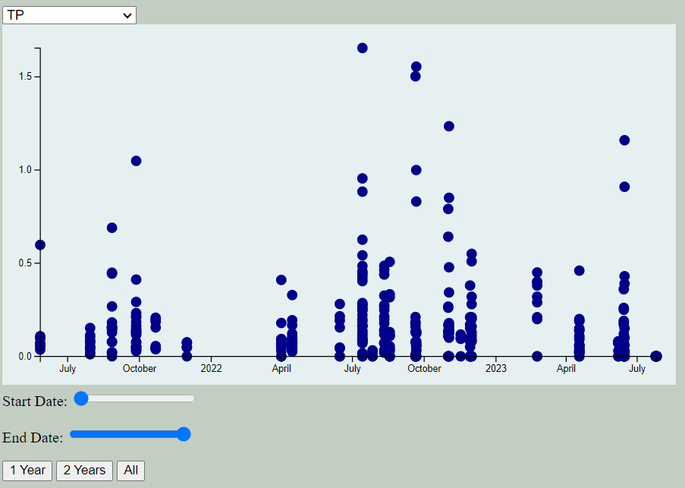

**Visualization 3 (Line Graph):**

* By using this graph, users can gain a clear understanding of the trends and patterns in their data over time. This can help to uncover important insights into environmental changes and inform decisions that promote positive outcomes.
* One can visualize two distinct lines, each representing a different parameter. This allows us to effectively compare and contrast the two parameters and identify any patterns or trends.
* The graph has two y-axis displaying the selected parameters, and the dates are shown on the x-axis.
* Data points on each line are represented by colored dots, such as red for TP and green for TN, making it easy to distinguish individual values.
* Hovering over the dots displays exact parameter values. While, clicking on a data point displays related information.
* Users can dynamically select different parameters using two dropdown menus placed at the top of the visualization.

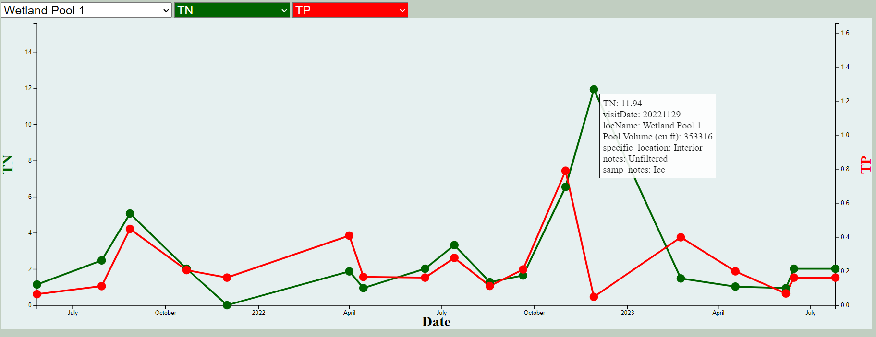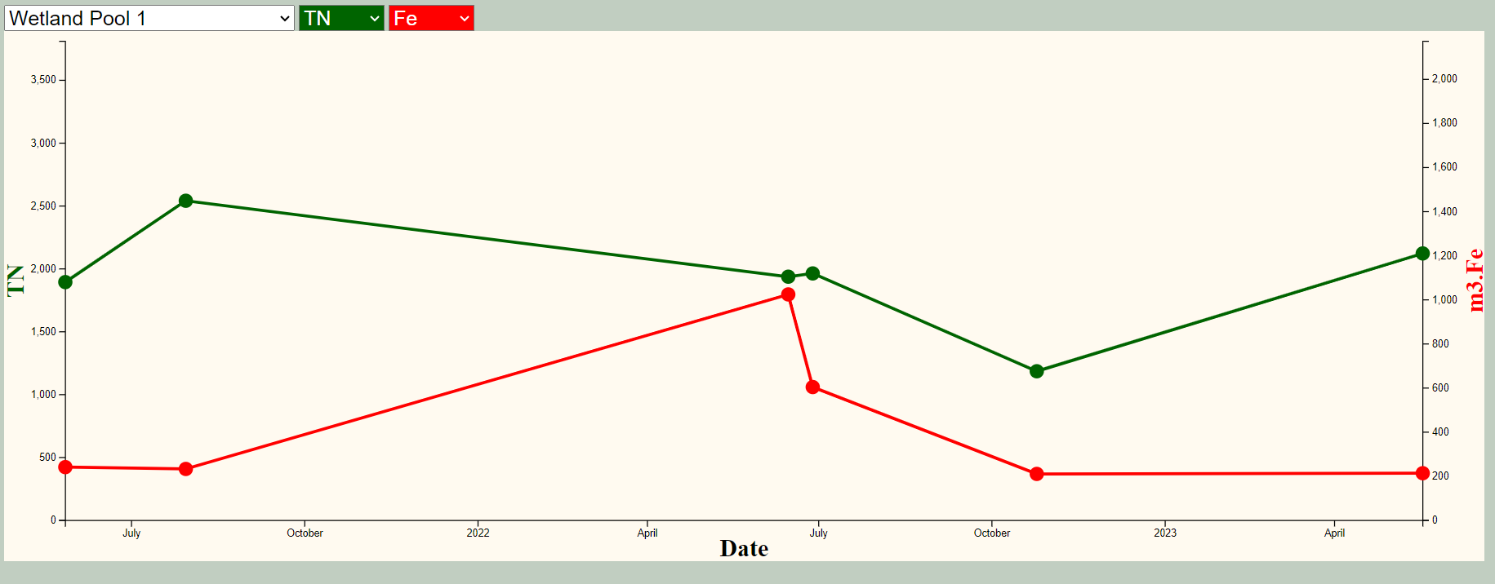

**Part III: Contributed for the team work**

My Contribution: